# **Usability Testing**

**Testing the user friendliness of an application is called Usability testing**

**Checking the user-friendliness, efficiency, and accuracy of the application is known as Usability Testing**

**Let us start with an example such that we have two applications A & B which are different but doing the same job. In this, we see which one is user friendly**

**Given below are some of the parameters we look into for testing. In this most of them are not measurable,**

* Speed
* Help
* Navigation should be simple
* Compatibility
* Look & feel
* Features
* Location of components
* One important parameter other than the above said parameters is “Effort needed to learn the application”.

**Suppose in the example, we understand the software A in 2 hrs, but we take 4hrs to understand B. Let us see different cases here**

* since we understand A in 2hrs, it becomes user friendly compared to B
* suppose look & feel is not good for A. In this case though, we understand A in 2hrs, we cannot say that A is user friendly.
* Therefore, we look into many parameters before we say user friendliness of a software

**What is Look and Feel**

The application should be such that it should be pleasant looking [ suppose if we have red color text in yellow background, definitely we don‟t feel like using it ] and make a feel to the end-user to use it

Let us now see some of the examples of Usability testing

1) Consider some of the examples below,

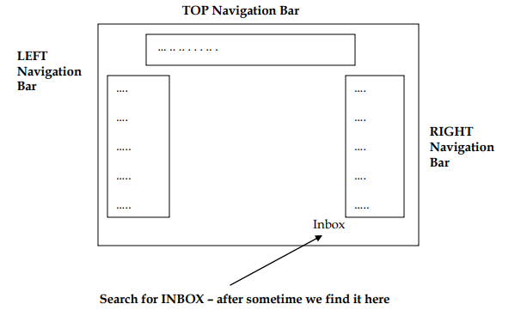

In this example, we see the Inbox – the most frequently used feature is not kept in the right place. End – users therefore search for the Inbox & after sometime, they find the Inbox lying somewhere down. This type of application may lose the customers because they are less user – friendly.

How to overcome this, See to it that the important features are placed in the left navigation bar and top navigation bar (This is normally followed)

Then we should see whether frequently used features are easily accessible (like Inbox, Compose Mail etc) While testing, we therefore have to list all the important features before we start testing an application

**Consider the sketch shown below,**

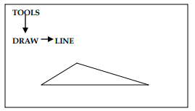

The end – user to draw the above sketch every time, he clicks Tools -> Draw -> Line for each line and finally he clicks Tools -> Draw -> Line to complete the sketch.

In this , we see the end-user wants tto draw a simple sketch, but he wastes his time in clicking each time the Tools -> Draw -> Line for the sketch. This becomes a waste of time for the end-user.

Therefore, while testing , we must make user friendly of the application by creating Tool bar which makes the job simple by clicking on the necessary tools instead of going & clicking each time Tool -> Draw -> Line

**Suppose we have a shopping website which has 10 pages of product like shown below**

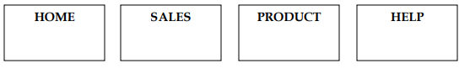

The question here is – after going to the 10th page – how do we come back to the 5th page ? – Do we click back – after – back – back -> NO -> then how do we do – Observe, To make user friendly application, we always have Bread Crumbs

**What are Bread Crumbs ?**

In each page, we will have a link to go to its respective page. Suppose we have seen all the 7 pages & we are in 8th page – that 8th page will have the link of all the 7 pages – so whatever page (Suppose 5th page) you like to visit, you click on the link in the 8th page & go to the 5th page.

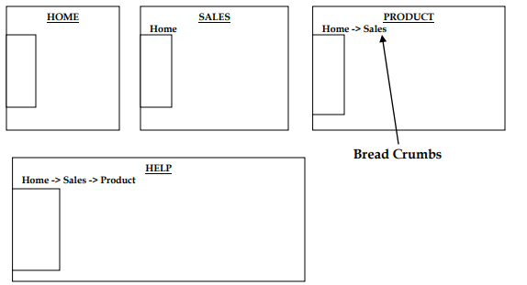

If a developer develops a pop – up window, always he should keep the Yes button in the beginning. If he swaps this, then there should be some valid reason behind it.

**How to conduct Usability testing? (OR) What process should we follow to do Usability testing?**

Prepare OR derive checklist (i.e, what are the points to be checked). If we don‟t prepare a checklist, we may miss some features in the application.

For Usability testing, we should prepare a genuine checklist specific to the product we develop

* For this application, one of the checklists includes color of already checked link should be changed to red
* All the images should have alt tag(Tooltip)
* All the pages should have link to Homepage
* Login feature should have Forgot Password link
* Should be able to access all the components.

While deriving a checklist, we should derive a common checklist which can be executed for all pages.

There is another caes where the customer gives the checklist for the application.

**Extra Information :- Must Read**

Nowadays, we have n-numbers of applications available in the application store in order to help people in their works.

And where they can gives a negative response or a poor rating, which leads a particular product towards their ends before it is downloaded or installed by a limited number of end-users.

In short, we can say that one bad review can damage all the resources, skill, extended hours of planning, enthusiasm to develop the product, and so on. which comes under the non-functional testing.

It is primarily used in user-centered interaction design on order to check the usability or ease of using a software product

The primary purpose of executing the usability testing is to check that the application should be easy to use for the end-user who is meant to use it

When we use usability testing, it makes sure that the developed software is straightforward while using the system without facing any problem and makes end-user life easier.

**It is also called User Experience (UX) Testing.**

**In Usability Testing, the user-friendliness can be described with the help of the following characteristics:**

**Easy to understand**- All the features of software or applications must be visible to the end-users.

**Easy to access-** To check how easily a user can use the different functionalities of the application.

**Look and feel-**

* The look and feel of the application should be excellent and attractive to get the user's interest
* The GUI of the software should be good because if the GUI is not well, the user may be lost his/her interest while using the application or the software.
* The quality of the product is up to the mark as given by the client.

**Faster to Access**

* The software should be faster while accessing, which means that the application's response time is quick.
* If the response time is slow, it might happen that the user got irritated. We have to ensure that our application will be loaded within 3 to 6 seconds of the response time.

**Effective Navigation**

* Good Internal Linking
* Informative header and footer
* Good search feature
* Effective navigation is the most significant aspect of the software. Some of the following aspects for effective navigation:

**Good Error Handling**

* While using the application, how often do users make mistakes and how easily can they recover from those errors.
* By showing the correct error message will help to enhance the user experience and usability of the application.

**Level of satisfaction –** This is a subjective attribute that deals with the satisfaction or the general opinion a user has about the product.

**Memorability** – To check how easily the user can remember the different flows of the application after exploring it for the first time.